Mini Project:
Fake Currency Detection Using Deep Learning (CNN)
Batch no :-Team 1
Names:
BOMMINENI SAI ANVESH REDDY (223251013)
BABLI HALDER (223251024)
PRATHIK HALDER (223251009)
MUTHYALA MANISHA (223251033)
PURNA NANDU(223251005)

Details:
Computer Science & Engineering
CSE A2- 6th Sem | 3rd Year
2023 - 2027 Batch
Guide Name:
Mr/Mrs :-Cherukuri Mahesh

Project Abstraction: Simplification of Project Intricacies.
Overview:
The Problem:
The circulation of counterfeit Indian currency notes is a serious issue that affects the country’s economy and public trust. Detecting fake currency manually requires trained personnel and special tools, and even then, mistakes can occur.
Proposed Solution & Technology Used:
This project proposes an automated system for detecting fake currency notes using Deep Learning. The system uses Convolutional Neural Networks (CNNs) with a transfer learning model called MobileNetV2 to analyze images of currency notes and identify whether they are genuine or fake.
Expected End Product:
The final outcome of this project is a software application that can accurately classify Indian currency notes as genuine or counterfeit. A simple user interface is also included for easy demonstration and usage.

ABSTRACT
Fake currency detection is a major concern for banks, businesses, and the general public, as the circulation of counterfeit notes can lead to financial losses and reduced trust in the monetary system. Traditional methods of detecting fake currency mainly rely on manual inspection by trained personnel using tools such as ultraviolet lamps, magnifying glasses, and watermark analysis. Although these methods are widely used, they are time-consuming, require expertise, and are prone to human error. As a result, there is a need for an automated and reliable solution.
In this project, a deep learning–based approach is proposed to automatically detect fake Indian currency notes using image classification techniques. The system uses a Convolutional Neural Network (CNN) with the MobileNetV2 architecture, which is a lightweight and efficient transfer learning model. Images of currency notes are processed and analyzed by the CNN to extract important visual features that help distinguish genuine notes from counterfeit ones. The trained model then classifies the input image as either genuine or fake.
The proposed system aims to provide a fast, accurate, and automated solution for fake currency detection. By reducing human involvement and minimizing errors, the system can assist financial institutions and users in identifying counterfeit currency more effectively and help control the circulation of fake notes.

PROBLEM DEFINITION
Overview
Real-World Relevance:
Fake currency circulation causes financial losses, increases fraud, and weakens trust in the monetary system. It is a serious problem for banks, shops, and common people.
Existing System & Drawbacks:
Current methods depend mainly on manual inspection by trained professionals using tools such as UV lamps and magnifying glasses. These methods are time-consuming, require expertise, and are not easily accessible to everyone.
Need for the Proposed System:
An automated system based on machine learning can provide faster and more consistent results. It can be used by non-experts and does not require special equipment, making fake currency detection more accessible.

EXISTING SYSTEM & NEED FOR ANEW
Existing System
- Manual checking of currency notes by bank officials
- Use of ultraviolet lamps and magnifying tools
- Dependence on trained and experienced personnel
Drawbacks
- Detection process is slow
- High possibility of human error
- Not suitable for use by the general public
Need for a New System
- Automation of the currency verification process
- Improved accuracy and reliability
- Simple and user-friendly system for wider use

OBJECTIVES
- To understand and apply deep learning concepts, especially Convolutional Neural Networks, for image classification tasks.
- To develop an automated system that can detect fake Indian currency notes from images.
- To reduce dependence on manual inspection and human expertise.
- To improve the accuracy and speed of fake currency detection.
- To design a simple user interface for easy interaction and demonstration.
- To study the effectiveness of transfer learning models such as MobileNetV2.
- To evaluate the feasibility of using deep learning solutions in real-world financial security applications.

LITERATURE SURVEY
- R. Kumar et al., “Fake Currency Detection Using Image Processing,” International Journal of Computer Applications, 2019. This paper discusses traditional image processing methods used for fake currency detection and explains their limitations.
- S. Patil and M. Patil, “Currency Recognition System Using CNN,” IEEE Conference, 2020. This work presents a CNN-based approach for currency recognition and shows improved accuracy compared to traditional techniques.
- A. Sharma et al., “Deep Learning Based Currency Authentication,” Springer, 2021. The authors explore deep learning models for currency authentication and highlight the robustness of CNNs.
- Howard et al., “MobileNets: Efficient Convolutional Neural Networks for Mobile Vision Applications,” Google Research, 2017. This paper introduces MobileNet, an efficient CNN architecture suitable for real-time applications.
- S. Gupta et al., “Image-Based Fake Currency Detection Using Deep Learning,” International Journal of Engineering Research, 2022. This study emphasizes the advantages of deep learning over rule-based systems for detecting counterfeit currency.

PROPOSED SYSTEM
Overview
Purpose of the System:
The main goal of the proposed system is to automatically identify whether an Indian currency note is genuine or fake using deep learning techniques.
Overcoming Existing Problems:
The system reduces the need for manual inspection and eliminates dependence on special tools and expert knowledge by using automated image analysis.
Key Features:
- Image-based fake currency detection
- High accuracy using CNN and transfer learning
- Fast and automated processing
- Low hardware and computational requirements
What Our System Does
- Takes an image of a currency note as input
- Performs image preprocessing such as resizing and normalization
- Extracts important features using a trained CNN model
- Classifies the note as genuine or fake
- Displays the result to the user
How It Overcomes Existing Problems
- Minimizes human error by automating detection
- Speeds up the verification process
- Can be used without specialized hardware or training

SYSTEM ARCHITECTURE
Overview
The system architecture includes image input, preprocessing, feature extraction using CNN, classification, and result display. Each step is designed to ensure efficient and accurate processing of currency images.
Flow:
- Currency image input
- Image preprocessing
- Feature extraction using CNN
- Classification of the image
- Display of result

ARCHITECTURE DESIGN

The system follows a modular design approach, where each component performs a specific function. This design imp roves scalability, flexibility, and ease of maintenance.
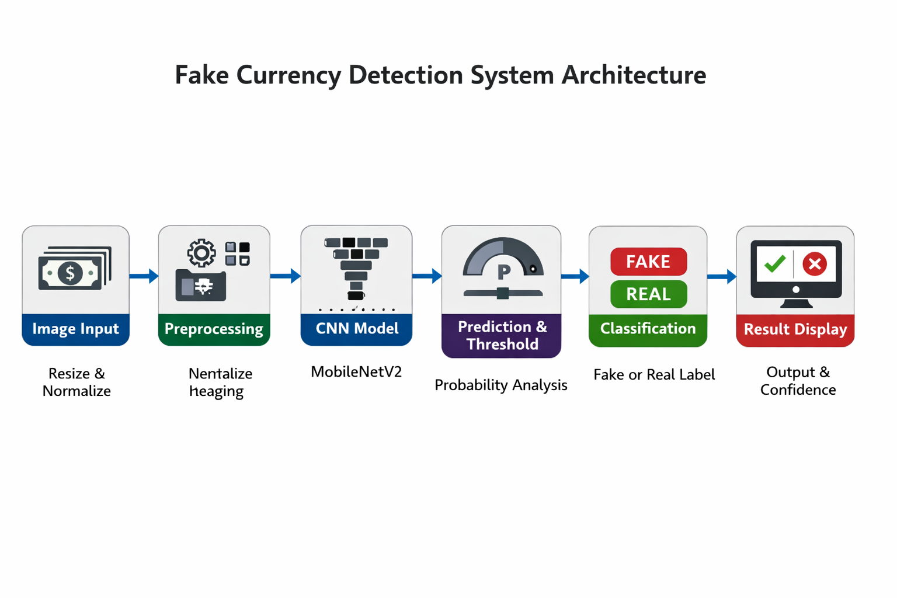

MODULE-WISE DESCRIPTION
Modules
- User Interface Module – Allows users to upload currency images and view prediction results.
- Data Management Module – Handles storage and management of currency image datasets.
- Preprocessing Module – Prepares images by resizing and normalizing them before model input.
- Machine Learning Module – Uses a CNN model to extract features and classify images.
- Model Storage Module – Stores trained deep learning models for reuse.
- Prediction Module – Generates the final output indicating whether the currency is fake or genuine.

TOOLS & TECHNOLOGY
- Programming Language: Python
- Deep Learning Framework: TensorFlow / Keras
- Model Used: MobileNetV2
- Frontend Technology: Streamlit
- Development Environment: Visual Studio Code (VS Code)
- Operating System: macOS / Windows

FEASIBILITY & CONCLUSION
Feasibility
The proposed fake currency detection system is technically and economically feasible. From a technical perspective, the system uses widely available deep learning frameworks such as TensorFlow and Keras, along with a lightweight pre-trained model (MobileNetV2), which can run efficiently on standard computers without requiring high-end hardware or GPUs. The dataset used is manageable in size, and the training and testing processes can be completed within reasonable time limits. From an economic perspective, the project relies entirely on open-source software tools, which reduces development costs and makes the solution affordable for academic and small-scale real-world use. Operational feasibility is also high, as the system is easy to use and does not require specialized training for end users.
Conclusion
This project demonstrates an effective application of deep learning techniques for fake currency detection. By using Convolutional Neural Networks and transfer learning, the proposed system provides an automated, accurate, and reliable alternative to traditional manual methods. The system reduces human effort, minimizes errors, and improves the speed of currency verification. Overall, the project successfully addresses a real-world financial security problem and lays a strong foundation for future enhancements such as real-time detection, mobile-based deployment, and support for additional currency denominations.

REFERENCES
- Howard, A. G., et al., “MobileNets: Efficient Convolutional Neural Networks for Mobile Vision Applications,” 2017.
- R. Kumar et al., “Fake Currency Detection Using Image Processing,” International Journal of Computer Applications, 2019.
- S. Patil and M. Patil, “Currency Recognition System Using CNN,” IEEE Conference, 2020.
- A. Sharma et al., “Deep Learning Based Currency Authentication,” Springer, 2021.
- William Estes (Ed.), Handbook of Learning and Cognitive Processes, Psychology Press, 2014.

